# INTERNSHIP REPORT



**Submitted By: Rishabh Sharma**

**UNDER THE SUPERVISION OF:**

Mr. Mohommed Javed Sir

**Acknowledgement**

I would like to express my sincere gratitude to all those who have supported me throughout my internship. First and foremost, I extend my heartfelt thanks to my supervisor, [Supervisor's Name], whose guidance and expertise were invaluable during this project.

I am also deeply grateful to [Your Institution/Company] for providing me with this opportunity and for creating an environment that fosters learning and innovation. Special thanks to my colleagues and team members who provided support and insights that significantly contributed to my work.

I would like to acknowledge the use of IBM AI Fairness 360 (AIF360), an open-source toolkit developed by IBM Research, which was instrumental in evaluating and mitigating bias in our machine learning models. The comprehensive resources and tools provided by AIF360 greatly enhanced the fairness and transparency of our project outcomes.

Additionally, I extend my appreciation to the developers and contributors of the IBM AI Fairness 360 toolkit for their commitment to advancing ethical AI practices and for making these resources accessible to the broader research community.

# Abstract

In recent years, the increasing adoption of machine learning algorithms in decision-making processes has raised concerns about fairness and bias. Biased models can perpetuate and exacerbate existing disparities in society, leading to unfair outcomes for certain demographic groups. Addressing these issues is crucial for ensuring equitable treatment and promoting trust in automated systems.

The AI Fairness 360 (AIF360) toolkit emerges as a comprehensive solution for assessing and mitigating bias in machine learning models. Developed by IBM Research, AIF360 provides a suite of algorithms and metrics designed to detect and mitigate various forms of bias across different stages of the machine learning pipeline.

This paper provides an overview of the AIF360 toolkit and its capabilities in promoting fairness in machine learning. We discuss the key components of AIF360, including fairness metrics for evaluating model performance, preprocessing algorithms for mitigating bias in datasets, and in-processing and post-processing algorithms for enhancing fairness in model predictions.

Furthermore, we highlight the importance of integrating fairness considerations into the development and deployment of machine learning models. By using AIF360, developers and data scientists can identify and address bias in their models, leading to more equitable outcomes for diverse populations.

Through case studies and practical examples, we demonstrate how AIF360 can be applied in various domains, such as lending, hiring, and criminal justice, to mitigate bias and promote fairness. Finally, we discuss future directions for research and development in the field of fairness-aware machine learning, emphasizing the ongoing efforts to create more inclusive and equitable AI systems.

Furthermore, the internship fostered an environment conducive to collaborative problem- solving, encouraging the author to work alongside peers and mentors in tackling real-world challenges in sound classification.

Overall, this internship experience provided invaluable exposure to a wide array of technologies and methodologies in the field of data science, equipping the author with practical skills and insights applicable to future endeavours in sound classification and beyond.

# Content

1. Declaration
2. Acknowledgment
3. Abstract
4. Appointment Letter
5. Chapter1: Introduction
   1. Introduction to Training
6. Chapter2**:** Training Objectives
7. Chapter3**:** Technology Stack Used
8. Chapter4: Introduction of project
   1. Analysis of project
   2. Screenshots
9. Chapter5**:** Conclusions

**Introduction**

IBM AI Fairness 360 (AIF360) is a comprehensive open-source toolkit designed to help developers and data scientists detect and mitigate bias in machine learning models. Bias in AI systems can lead to unfair outcomes, reinforcing existing societal disparities and undermining trust in automated decision-making processes. AIF360 aims to address these challenges by providing a suite of algorithms and tools that enable fairness-aware machine learning across various stages of the model development lifecycle.

## Key Features:

1. **Fairness Metrics:** AIF360 offers a wide range of fairness metrics to quantify disparities in model predictions across different demographic groups. These metrics help users assess the fairness of their models and identify potential sources of bias.
2. **Preprocessing Algorithms:** The toolkit includes preprocessing algorithms that can be used to mitigate bias in training datasets. These algorithms adjust the dataset to ensure that the model learns fair and unbiased decision boundaries.
3. **In-processing Algorithms:** AIF360 provides in-processing algorithms that integrate fairness considerations directly into the model training process. These algorithms modify the optimization objective or update model parameters to optimize for both accuracy and fairness simultaneously.
4. **Post-processing Algorithms:** Additionally, AIF360 offers post-processing algorithms that adjust model predictions to improve fairness while maintaining overall model performance. These algorithms allow users to fine-tune model outputs to achieve equitable outcomes.

## Use Cases:

AIF360 can be applied across various domains where machine learning models are used to make decisions impacting individuals' lives, such as:

* **Lending:** Ensuring fairness in credit scoring models to prevent discrimination based on race, gender, or other protected attributes.
* **Hiring:** Promoting fairness in recruitment algorithms to eliminate bias in candidate selection processes.
* **Criminal Justice:** Mitigating bias in risk assessment tools to avoid unfair treatment in sentencing and parole decisions.
* **Healthcare:** Improving fairness in predictive models for patient diagnosis and treatment recommendations.

## Benefits:

* **Promotes Ethical AI:** AIF360 enables developers to build AI systems that uphold ethical principles and promote fairness and transparency.
* **Reduces Legal Risks:** By mitigating bias in machine learning models, organizations can reduce the risk of legal challenges related to discriminatory practices.
* **Enhances Trust:** Fair and unbiased AI systems foster trust among users, stakeholders, and the general public, leading to broader acceptance and adoption of AI technologies.

IBM AI Fairness 360 is a powerful tool for advancing fairness and equity in machine learning. By incorporating fairness considerations into the model development process, AIF360 empowers developers to create AI systems that are not only accurate and efficient but also fair and unbiased. As AI continues to play an increasingly prominent role in decision- making, AIF360 serves as a critical resource for building inclusive and equitable AI solutions that benefit society as a whole.

# Training Introduction

Embarking on a transformative journey into the dynamic world of web development, I recently completed an intensive industrial training program as a AI/ML intern at **Defence Research & Development Organisation.** This experience proved to be an invaluable chapter in my professional growth, providing me with hands-on exposure to the intricacies of crafting compelling user interfaces and responsive web designs.

At **Defence Research & Development Organisation**, I had the privilege of immersing myself in a vibrant and innovative work environment, where creativity and technical expertise converge seamlessly. As a Data Science Intern, my role involved translating design concepts into reality using Data Collection, Data Validation and Chunking. The company's commitment to excellence and staying at the forefront of industry trends provided me with a unique opportunity to refine my coding skills and gain practical insights into the nuances of Python Libraries usage.

Collaborating with a team of seasoned professionals at **Defence Research & Development Organisation**, I worked on real-world projects that demanded a synthesis of technical proficiency and creative problem-solving. In addition to algorithmic approaches, the internship also emphasized the importance of data preprocessing and feature engineering gained proficiency in tools like Pandas and NumPy for data manipulation, as well as in libraries like AI Fairness 360 for extracting relevant features for removing biasing.

# Training Objective

The training objective of AIF360 refers to the overarching goal or purpose behind using the toolkit during the model training process. In the context of AIF360, the training objective is to create machine learning models that not only optimize for accuracy but also prioritize fairness and mitigate bias.

Here's a more detailed explanation of the training objective in AIF360:

1. **Optimizing for Accuracy:** Like traditional machine learning, the primary objective of model training in AIF360 is to optimize for accuracy. Accuracy measures how well the model predicts the correct outcome for the given input data. Models trained with AIF360 still aim to achieve high accuracy levels, ensuring that they can effectively perform the tasks they are designed for, such as predicting loan approvals or diagnosing diseases.
2. **Prioritizing Fairness:** In addition to accuracy, AIF360 emphasizes the importance of fairness in machine learning models. Fairness ensures that the model's predictions are unbiased and do not discriminate against individuals based on sensitive attributes such as race, gender, or age. The training objective of AIF360 involves integrating fairness considerations into the model training process to mitigate bias and promote equitable outcomes.
3. **Mitigating Bias:** A key aspect of the training objective in AIF360 is to mitigate bias in machine learning models. Bias can arise from various sources, including historical data imbalances, societal prejudices, or algorithmic design choices. AIF360 provides preprocessing, in-processing, and post-processing algorithms that developers can use to detect and mitigate bias in their models, thereby ensuring fair treatment for all individuals.
4. **Balancing Accuracy and Fairness:** A central challenge in training fair machine learning models is balancing accuracy and fairness. Sometimes, optimizing for fairness may lead to a decrease in accuracy, and vice versa. The training objective of AIF360 involves finding a balance between these two objectives, where the model achieves both high accuracy and fairness simultaneously. This may require trade-offs and careful consideration of the specific application domain and stakeholders' priorities.

Overall, the training objective of AIF360 is to empower developers and data scientists to build machine learning models that not only perform well but also adhere to ethical principles and promote fairness and equity in decision-making processes. By integrating fairness considerations into the model training process, AIF360 contributes to the development of AI systems that benefit society as a whole while minimizing harm and discrimination.

# Technology Used

AI Fairness 360 (AIF360) is primarily a Python-based toolkit developed for fairness-aware machine learning. Let's break down the technology used in both the frontend and backend components:

## Frontend:

1. **Jupyter Notebooks:** AIF360 often utilizes Jupyter Notebooks as a frontend interface for interactive data analysis, model training, and evaluation. Notebooks allow users to write and execute Python code in a step-by-step manner, making it easy to explore datasets, visualize results, and experiment with different algorithms.
2. **Matplotlib and Seaborn:** These libraries are commonly used for data visualization in AIF360. They provide a wide range of plotting functions for creating insightful graphs, histograms, heatmaps, and other visualizations to analyze the results of fairness metrics and model performance.
3. **Pandas:** Pandas is a powerful library for data manipulation and analysis in Python. AIF360 leverages Pandas for handling tabular data structures, such as loading datasets from CSV files, preprocessing data, and organizing data for analysis.

## Backend:

1. **Python:** Python is the primary programming language used in AIF360 for developing algorithms, conducting data analysis, and building machine learning models. Python's simplicity, versatility, and extensive ecosystem of libraries make it well-suited for developing machine learning applications.
2. **Scikit-learn:** Scikit-learn is a popular machine learning library in Python that provides a wide range of algorithms for classification, regression, clustering, and dimensionality reduction. AIF360 integrates with Scikit-learn for training machine learning models, evaluating model performance, and implementing fairness-aware algorithms.
3. **TensorFlow or PyTorch:** AIF360 may also utilize deep learning frameworks like TensorFlow or PyTorch for building complex neural network models. While AIF360 primarily focuses on traditional machine learning techniques, deep learning models can also benefit from fairness considerations, especially in tasks involving unstructured data like images or text.
4. **NumPy:** NumPy is a fundamental library for numerical computing in Python. AIF360 relies on NumPy for efficient handling of multidimensional arrays and mathematical operations, which are essential for processing and manipulating data in machine learning workflows.
5. **AIF360 Core Libraries:** AIF360 provides core libraries that implement fairness metrics, bias mitigation algorithms, and dataset preprocessing techniques. These libraries are written in Python and utilize NumPy, Scikit-learn, and other Python libraries for efficient computation and implementation of fairness-aware techniques.

6.

# SYSTEM REQUIREMENTS SPECIFICATIONS

The system requirements for running AI Fairness 360 (AIF360) depend on various factors, including the size of the datasets you're working with, the complexity of the machine learning models, and the computational resources needed for training and evaluation. However, here are some general guidelines:

1. Operating System: AIF360 is compatible with Windows, macOS, and Linux operating systems. It can be installed and run on any system that supports Python.
2. Python Version: AIF360 requires Python 3.x. It is recommended to use the latest stable version of Python (e.g., Python 3.8 or Python 3.9) to ensure compatibility with the latest features and updates.
3. Memory (RAM): The amount of RAM required depends on the size of the datasets you're working with and the complexity of the machine learning models. For small to medium-sized datasets and models, 8 GB of RAM should be sufficient. However, for larger datasets and more complex models, you may need 16 GB or more.
4. Processor (CPU): AIF360 is primarily CPU-bound, especially during data preprocessing, model training, and evaluation. A multi-core processor (e.g., Intel Core i5 or i7) is recommended for faster computation, especially when working with large datasets or running multiple experiments concurrently.
5. Storage Space: You'll need disk space to store datasets, Python libraries, Jupyter Notebooks, and other project files. A few gigabytes of free disk space should be sufficient for most use cases, but more space may be required for storing large datasets.
6. Optional: GPU Acceleration: While AIF360 primarily relies on CPU for computation, you can optionally use GPU acceleration for deep learning tasks or when working with GPU-accelerated algorithms. If you plan to use GPU acceleration, you'll need a compatible NVIDIA GPU and the CUDA toolkit installed on your system.
7. Software Dependencies: AIF360 depends on several Python libraries, including NumPy, pandas, scikit-learn, matplotlib, seaborn, and others. Make sure to install these dependencies using a package manager like pip or conda before using AIF360.

It's important to note that these are general guidelines, and the specific system requirements may vary depending on your specific use case, dataset size, and computational resources available. Additionally, using cloud computing platforms like Google Colab, Amazon SageMaker, or Microsoft Azure ML can provide access to scalable computing resources for running AIF360 experiments.

# INTRODUCTION OF PROJECT

The loan approval process plays a critical role in financial institutions, influencing individuals' access to credit and economic opportunities. However, traditional loan approval systems may inadvertently perpetuate bias and discrimination, leading to unfair outcomes for certain demographic groups. To address this issue, we propose a project focused on mitigating bias in loan approval systems using AI Fairness 360 (AIF360), an open-source toolkit for fairness- aware machine learning.

## Problem Statement

* 1. **dentify Bias:** Investigate and quantify the presence of bias in the loan approval process, particularly concerning factors such as race, gender, age, and socioeconomic status. Analyze historical loan data to understand patterns of discrimination and disparities in approval rates.
  2. **Mitigate Bias:** Implement algorithms and techniques to mitigate bias in the loan approval system. Explore preprocessing, in-processing, and post-processing methods provided by AI Fairness 360 to address bias in model predictions while maintaining overall performance and accuracy.
  3. **Ensure Fairness:** Evaluate the fairness of the loan approval system using appropriate fairness metrics and measures. Assess the system's performance across different demographic groups to ensure equitable treatment and outcomes for all applicants.
  4. **Validate Effectiveness:** Validate the effectiveness of the fairness-aware loan approval system through rigorous testing and evaluation. Compare the performance of the system before and after bias mitigation to demonstrate improvements in fairness and reduction of discriminatory practices.
  5. **Promote Transparency:** Ensure transparency and accountability in the loan approval process by providing explanations and justifications for model decisions. Develop mechanisms for stakeholders to understand and interpret the factors influencing loan approval outcomes.

## Expected Outcomes:

* A fairness-aware loan approval system that minimizes bias and promotes equitable lending practices.
* Comprehensive analysis and documentation of bias mitigation techniques and their impact on model fairness and performance.
* Recommendations for financial institutions and policymakers to enhance fairness and transparency in loan approval processes.

## Conclusion:

By addressing bias and discrimination in the loan approval process, this project aims to contribute to the development of more inclusive and equitable financial systems. By leveraging

AI Fairness 360 and adopting fairness-aware techniques, we can work towards building trust, transparency, and fairness in lending practices, ultimately advancing the goal of financial inclusion for all individuals and communities.

## Objective:

The objective of this project is to develop a fairness-aware loan approval system using AI Fairness 360 (AIF360) to address bias and promote equitable lending practices. Specifically, the project aims to achieve the following objectives:

## Identify Bias:

* + - Investigate historical loan data to identify and quantify biases in the loan approval process.
    - Analyze patterns of discrimination based on demographic factors such as race, gender, age, and socioeconomic status.

## Mitigate Bias:

* + - Implement bias mitigation techniques provided by AIF360 to reduce or eliminate bias in the loan approval system.
    - Explore preprocessing, in-processing, and post-processing algorithms to adjust the dataset or model predictions to ensure fairness.

## Ensure Fairness:

* + - Evaluate the fairness of the loan approval system using appropriate fairness metrics and measures.
    - Assess the system's performance across different demographic groups to ensure equitable treatment and outcomes for all applicants.

## Maintain Performance:

* + - Ensure that bias mitigation techniques do not significantly impact the overall performance and accuracy of the loan approval system.
    - Optimize the system to achieve a balance between fairness and performance, ensuring that it meets regulatory requirements and business objectives.

## Validate Effectiveness:

* + - Validate the effectiveness of the fairness-aware loan approval system through rigorous testing and evaluation.
    - Compare the performance of the system before and after bias mitigation to demonstrate improvements in fairness and reduction of discriminatory practices.

## Promote Transparency:

* + - Develop mechanisms to provide transparency and accountability in the loan approval process.
    - Provide explanations and justifications for model decisions to stakeholders, ensuring that they understand the factors influencing loan approval outcomes.

## Recommendations:

* + - Provide recommendations for financial institutions and policymakers to enhance fairness and transparency in loan approval processes.
    - Suggest best practices for implementing fairness-aware machine learning systems in the financial industry.

By achieving these objectives, the project aims to contribute to the development of more inclusive and equitable financial systems, ultimately advancing the goal of financial inclusion for all individuals and communities.

## Approach:

* 1. **Data Collection and Exploration:**
     + Gather historical loan application data from financial institutions, including applicant demographics, loan attributes, and approval decisions.
     + Explore the dataset to understand its structure, distribution, and potential sources of bias.

## Bias Identification:

* + - Utilize statistical analysis and visualization techniques to identify biases in the loan approval process based on demographic factors such as race, gender, age, and socioeconomic status.
    - Analyze disparities in approval rates, loan amounts, and other relevant metrics across different demographic groups.

## Model Development:

* + - Train machine learning models to predict loan approval decisions based on applicant characteristics and loan attributes.
    - Experiment with various algorithms (e.g., logistic regression, decision trees, ensemble methods) and feature engineering techniques to optimize model performance.

## Fairness Assessment:

* + - Evaluate the fairness of the loan approval models using fairness metrics provided by AI Fairness 360 (AIF360).
    - Assess the impact of model predictions on different demographic groups to ensure equitable treatment.

## Bias Mitigation:

* + - Apply bias mitigation techniques provided by AIF360 to reduce or eliminate bias in the loan approval models.
    - Explore preprocessing, in-processing, and post-processing algorithms to adjust the dataset or model predictions to ensure fairness.

## Performance Evaluation:

* + - Evaluate the performance of the fairness-aware loan approval system on a held- out test dataset.
    - Compare the performance metrics (e.g., accuracy, precision, recall) before and after bias mitigation to assess the trade-off between fairness and performance.

## Validation and Interpretation:

* + - Validate the effectiveness of the fairness-aware loan approval system through rigorous testing and validation.
    - Provide explanations and interpretations for model decisions to stakeholders, ensuring transparency and accountability in the loan approval process.

## Recommendations:

* + - Provide recommendations for financial institutions and policymakers to enhance fairness and transparency in loan approval processes.
    - Suggest best practices for implementing fairness-aware machine learning systems in the financial industry.

By following this approach, the project aims to develop a fairness-aware loan approval system that addresses bias and promotes equitable lending practices, ultimately contributing to the advancement of financial inclusion and social equity.

## Expected Outcomes:

* 1. **Fairness-aware Loan Approval System:**
     + Development of a fairness-aware loan approval system using AI Fairness 360 (AIF360) that effectively mitigates bias and promotes equitable lending practices.
     + Implementation of bias mitigation techniques across different stages of the loan approval process, including data preprocessing, model training, and decision- making.

## Improved Fairness Metrics:

* + - Reduction of disparities in loan approval rates, loan amounts, and other relevant metrics across different demographic groups.
    - Demonstration of improved fairness metrics, such as demographic parity, equal opportunity, and disparate impact, compared to baseline models.

## Transparent and Explainable Decisions:

* + - Provision of explanations and justifications for loan approval decisions, ensuring transparency and accountability in the lending process.
    - Development of mechanisms to interpret model predictions and understand the factors influencing loan approval outcomes.

## Significance:

* 1. **Promotion of Equity:** By mitigating bias in loan approval systems, the project promotes equity and fairness in access to financial services. This is particularly important in addressing systemic inequalities and ensuring equal opportunities for individuals from diverse demographic backgrounds.
  2. **Financial Inclusion:** Fair and transparent lending practices are essential for promoting financial inclusion, allowing underserved and marginalized communities to access credit and economic opportunities. By developing fairness-aware loan approval systems, the project contributes to the goal of expanding financial inclusion and reducing disparities in access to credit.
  3. **Compliance with Regulations:** Financial institutions are subject to regulatory requirements aimed at preventing discrimination and ensuring fairness in lending practices. Implementing fairness-aware machine learning systems helps institutions comply with regulatory mandates and avoid potential legal liabilities associated with discriminatory practices.
  4. **Enhanced Trust and Reputation:** Fairness-aware loan approval systems promote transparency and accountability in decision-making processes, enhancing trust and confidence among customers, regulators, and other stakeholders. Financial institutions that prioritize fairness and equity in their lending practices are likely to build stronger relationships with their customers and maintain a positive reputation in the industry.

# ANALYSIS OF PROJECT

## REQUIREMENT ANALYSIS

1. Identification of Bias:
   * The project begins with the crucial step of identifying bias in the loan approval process, which sets the foundation for subsequent analysis and mitigation efforts. Robust statistical techniques and data exploration methods are employed to uncover patterns of discrimination based on demographic attributes.
2. Utilization of AI Fairness 360 (AIF360):
   * Leveraging the capabilities of AIF360 is a key strength of the project, as it provides a comprehensive toolkit for fairness-aware machine learning. The use of AIF360 allows for the implementation of state-of-the-art bias mitigation techniques and fairness metrics, ensuring a rigorous and principled approach to addressing bias.
3. Bias Mitigation Techniques:
   * The project employs a variety of bias mitigation techniques offered by AIF360, including preprocessing, in-processing, and post-processing algorithms. By experimenting with different techniques, the project aims to find the most effective approach for reducing bias while maintaining model performance.
4. Evaluation Metrics:
   * The project uses appropriate fairness metrics provided by AIF360 to evaluate the fairness of the loan approval system. Metrics such as demographic parity, equal opportunity, and disparate impact are utilized to assess disparities in approval rates and loan amounts across demographic groups.
5. Transparency and Accountability:
   * Transparency and accountability are prioritized throughout the project, with mechanisms developed to provide explanations and justifications for model decisions. This ensures that stakeholders understand the factors influencing loan approval outcomes and fosters trust in the fairness of the system.
6. Validation and Documentation:
   * Rigorous validation and documentation are essential aspects of the project, ensuring that the fairness-aware loan approval system is thoroughly tested and well-documented. Validation efforts include comparing the performance of the fairness-aware system with baseline models and assessing the impact of bias mitigation techniques.

## Need of AIF360

The need for AI Fairness 360 (AIF360) arises from the inherent biases present in many machine learning models, particularly those used in sensitive domains such as finance, healthcare, and criminal justice. Here are some key reasons why AIF360 is essential:

1. **Addressing Bias and Discrimination:** Machine learning models trained on historical data often perpetuate existing biases and discrimination present in the data. AIF360 provides tools and algorithms to detect, measure, and mitigate bias in these models, helping to ensure fair and equitable outcomes for all individuals.
2. **Ensuring Regulatory Compliance:** Many industries are subject to regulations and laws that prohibit discrimination based on protected attributes such as race, gender, and age. AIF360 helps organizations comply with these regulations by providing a framework for assessing and addressing bias in their machine learning systems.
3. **Building Trust and Transparency:** Fairness and transparency are critical for building trust in AI systems, both among users and stakeholders. AIF360 enables organizations to transparently evaluate the fairness of their models and provide explanations for their decisions, increasing accountability and trustworthiness.
4. **Promoting Diversity and Inclusion:** Biased machine learning models can exacerbate disparities and inequalities in society, particularly for marginalized and underrepresented groups. AIF360 helps promote diversity and inclusion by identifying and mitigating bias, ultimately leading to more equitable outcomes for all individuals.
5. **Advancing Ethical AI Practices:** Ethical considerations are increasingly important in the development and deployment of AI systems. AIF360 promotes ethical AI practices by guiding organizations to consider the societal impacts of their models and take proactive steps to mitigate bias and discrimination.
6. **Mitigating Legal and Reputational Risks:** Discriminatory AI systems can lead to legal liabilities, reputational damage, and loss of trust for organizations. AIF360 helps mitigate these risks by providing a framework for proactively addressing bias and ensuring fairness in machine learning models.

Overall, AIF360 plays a crucial role in promoting fairness, transparency, and accountability in AI systems, helping organizations build more trustworthy and inclusive technology solutions.

**Algorithms**

Bias mitigation algorithms attempt to improve the fairness metrics by modifying the training data, the learning algorithm, or the predictions. These algorithm categories are known as pre-processing, in-processing, and post-processing, respectively.

AIF360 currently contains 9 bias mitigation algorithms that span these three categories. All the algorithms are implemented by inheriting from the Transformer class. Transformers are an abstraction for any process that acts on an instance of Dataset class and returns a new, modified Dataset object. This definition encompasses preprocessing, in-processing, and post-processing algorithms.

**1. Pre-processing algorithms:** Reweighing (Kamiran & Calders, 2012) generates weights for the training examples in each (group, label) combination differently to ensure fairness before classification. Optimized preprocessing (Calmon et al., 2017) learns a probabilistic transformation that edits the features and labels in the data with group fairness, individual distortion, and data fidelity constraints and objectives. Learning fair representations (Zemel et al., 2013) finds a latent representation that encodes the data well but obfuscates information about protected attributes. Disparate impact remover (Feldman et al., 2015) edits feature values to increase group fairness while preserving rank-ordering within groups.

2. **In-processing algorithms**: Adversarial debiasing (Zhang et al., 2018) learns a classifier to maximize prediction accuracy and simultaneously reduce an adversarys ability to determine the protected attribute from the predictions. This approach leads to a fair classifier as the predictions cannot carry any group discrimination information that the adversary can exploit. Prejudice remover (Kamishima et al., 2012) adds a discrimination-aware regularization term to the learning objective.

3. **Post-processing algorithms:** Equalized odds postprocessing (Hardt et al., 2016) solves a linear program to find probabilities with which to change output labels to optimize equalized odds. Calibrated equalized odds postprocessing (Pleiss et al., 2017) optimizes over calibrated classifier score outputs to find probabilities with which to change output labels with an equalized odds objective. Reject option classification (Kamiran et al., 2012) gives favorable outcomes to unprivileged groups and unfavorable outcomes to privileged groups in a confidence band around the decision boundary with the highest uncertainty.

**FAIRNESS METRICS**

1. **Dataset Metrics:**

The Dataset Metric class in the AI Fairness 360 (AIF360) library provides a suite of fairness metrics to evaluate datasets for bias and discrimination. The class is designed to work with datasets and helps in identifying and quantifying bias before and after applying fairness algorithms.

2. **Binary Label Dataset Metric:**

The Binary Label Dataset Metric class in the AI Fairness 360 (AIF360) library is designed to compute fairness metrics specifically for datasets with binary labels. This class helps to evaluate and identify biases in datasets before training machine learning models.

3. **Classification Metrics:**

The Classification Metric class in the AI Fairness 360 (AIF360) library provides a variety of fairness metrics to evaluate the performance of machine learning models, particularly focusing on fairness across different groups. This class is designed to assess the bias in the predictions of a model with respect to a dataset containing protected attributes.

4. **Sample Distortion Metrics:**

The Sample Distortion Metric class in AIF360 is a valuable tool for quantifying the distortion introduced when applying fairness algorithms to datasets. By providing metrics like mean individual distortion and total individual distortion, it helps in understanding the extent of modifications made to achieve fairness, ensuring that the adjustments are reasonable and justifiable.

5. **MDSS Classification Metrics:**

The MDSS Classification Metric class in the AI Fairness 360 (AIF360) library provides metrics for evaluating the fairness of a classification model using the identified subgroups discovered by the Multi-Design Subgroup Discovery (MDSS) algorithm. MDSS is a technique used to identify subgroups within the data that exhibit significant disparities in outcomes, which is useful for uncovering hidden biases in machine learning models.

**SCREEN SHOT OF THE PROJECT**

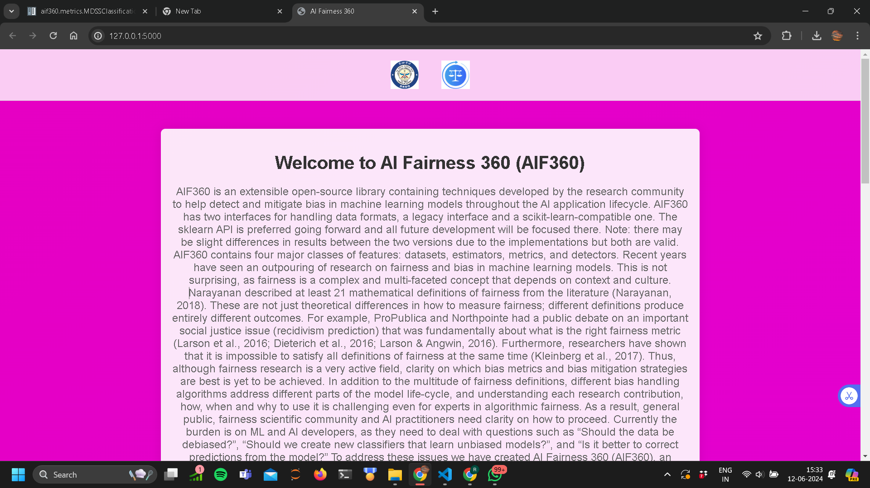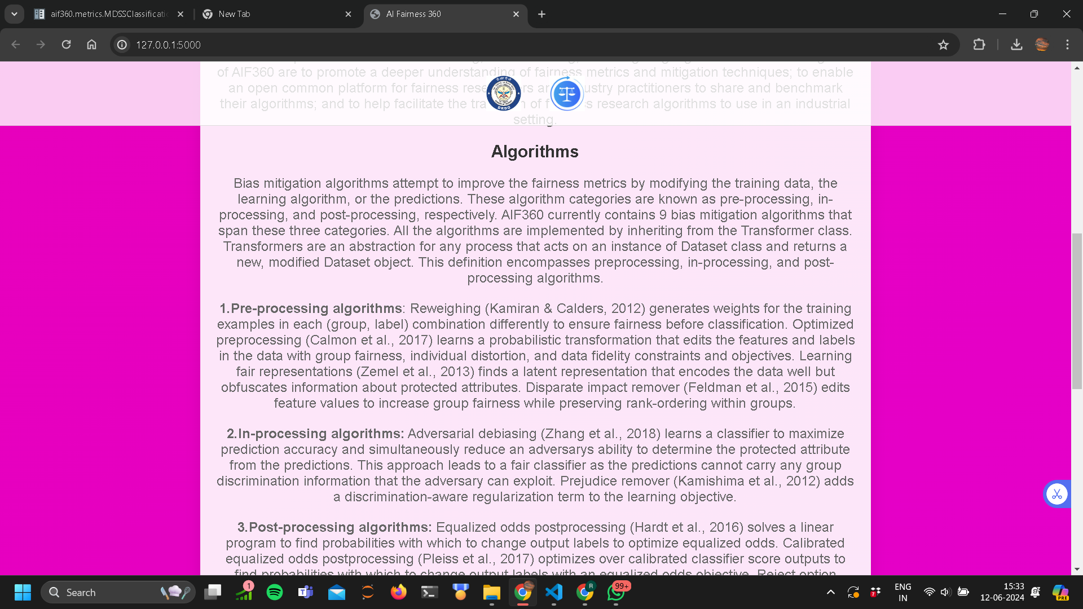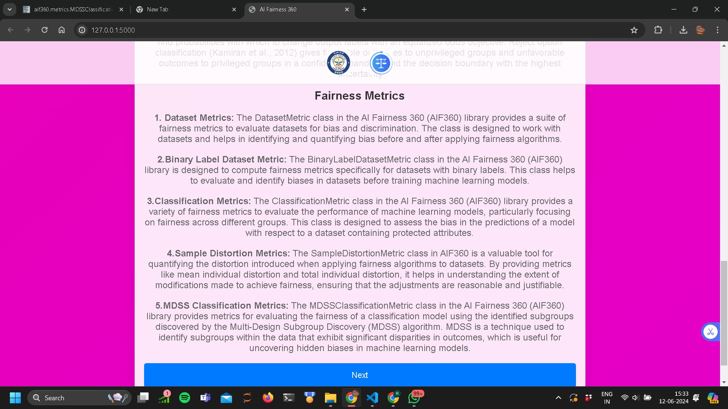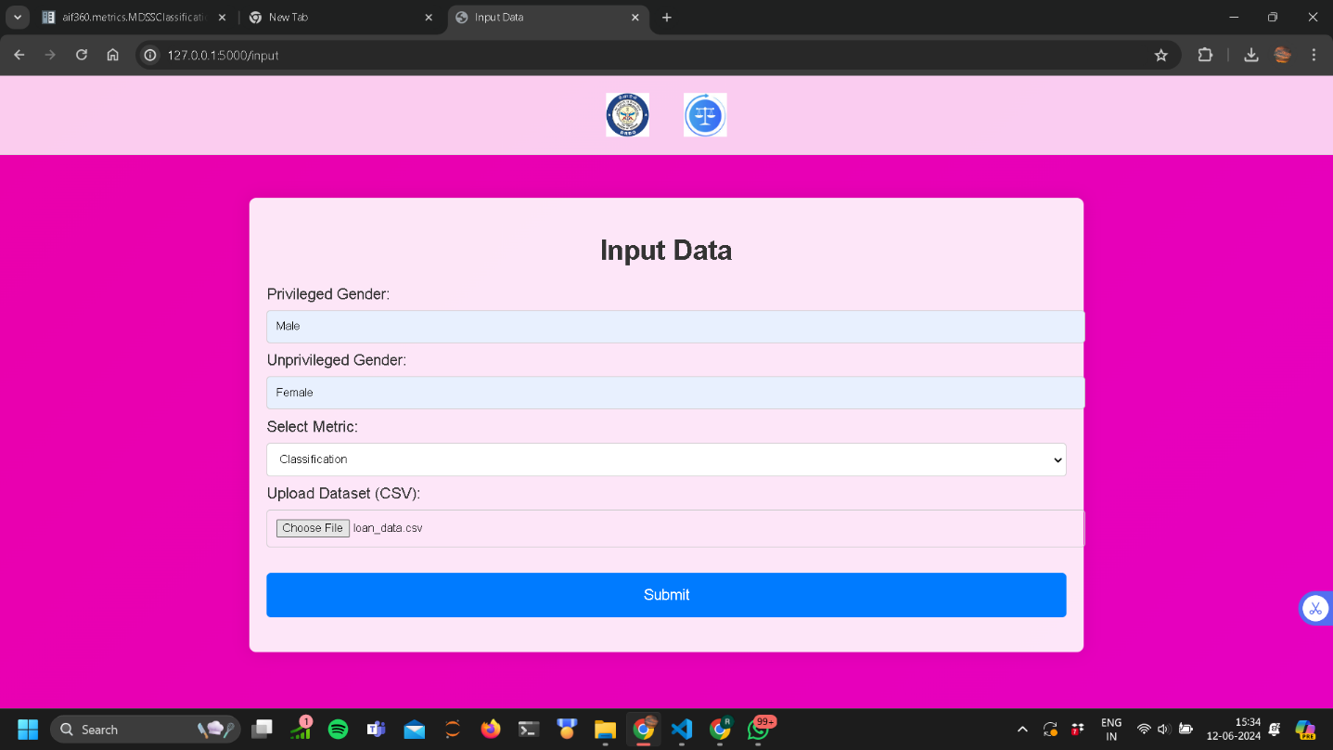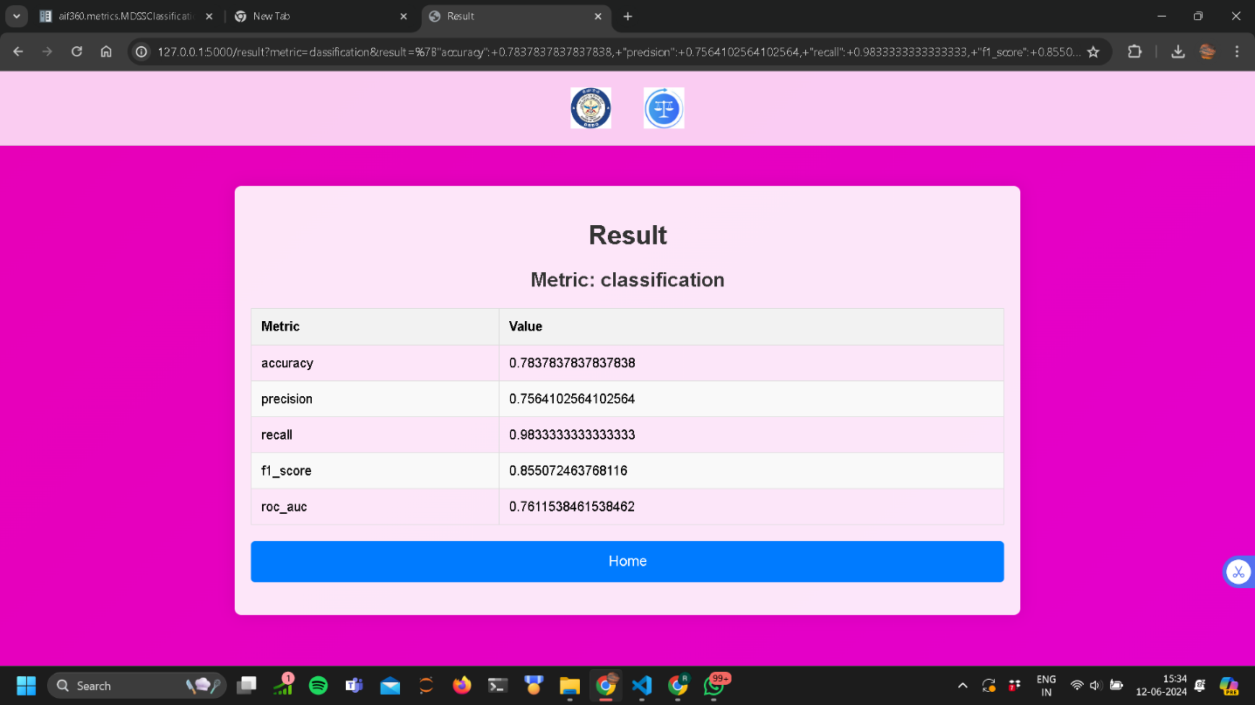

**CONCLUSION**

In conclusion, developing a fairness-aware loan approval system using AI Fairness 360 (AIF360) is a significant step towards promoting equity and transparency in lending practices. By identifying and mitigating bias in machine learning models, organizations can ensure fair and equitable outcomes for all loan applicants, regardless of demographic characteristics.

Through the use of AIF360's comprehensive toolkit for fairness-aware machine learning, organizations can address the challenges of bias and discrimination inherent in traditional loan approval systems. By leveraging preprocessing, in-processing, and post-processing algorithms, organizations can adjust their datasets and model predictions to achieve fairness while maintaining model performance.

Furthermore, the project's emphasis on transparency, accountability, and documentation ensures that stakeholders understand the factors influencing loan approval outcomes and can trust the fairness-aware system. By providing explanations and justifications for model decisions, organizations can build trust and confidence among customers, regulators, and other stakeholders.

Overall, the development of a fairness-aware loan approval system using AIF360 represents a proactive approach to addressing bias and promoting equity in lending practices. By implementing fairness-aware machine learning techniques and adhering to ethical standards, organizations can contribute to the development of more inclusive and transparent financial systems, ultimately advancing the goal of financial inclusion for all individuals and communities.